Project Report Format

INTRODUCTION
  - Project Overview
Intelligent SQL is a smart database query assistant that converts natural language queries into structured SQL queries automatically.
The system helps users interact with databases without requiring deep knowledge of SQL syntax.
It uses Natural Language Processing (NLP) techniques and query parsing mechanisms to understand user input and generate accurate SQL statements such as SELECT, INSERT, UPDATE, DELETE, JOIN, and aggregation queries.The system is designed to improve database accessibility for non-technical users and increase productivity for developers.

  - Purpose
The main purpose of Intelligent SQL is:
- To reduce dependency on manual SQL writing
- To help non-technical users retrieve data easily
- To minimize syntax errors
- To improve query efficiency
- To speed up database interaction

IDEATION PHASE
2.1 Problem Statement
Many users struggle to write correct SQL queries due to:
- Complex syntax
- Lack of technical knowledge
- Errors in query structure
- Time consumption in writing long queries
There is a need for a system that converts plain English into SQL automatically.

2.2 Empathy Map Canvas
User Thinks:
- SQL is difficult
- I need data quickly
User Feels:
- Confused with joins
- Afraid of syntax errors
User Says:
- “I just want sales data for last month”
- “How to filter records?”
User Does:
- Searches online
- Tries trial-and-error queries

2.3 Brainstorming
Possible Solutions Discussed:
- Chatbot-based SQL assistant
- AI-powered query generator
- Drag-and-drop query builder
- Voice-based SQL generator
Final idea selected:
AI-powered Natural Language to SQL Converter

REQUIREMENT ANALYSIS
3.1 Customer Journey Map
- User logs in
- Enters natural language query
- System processes input
- SQL query generated
- Results displayed
- User downloads/export data

3.2 Solution Requirement
Functional Requirements:
- Accept natural language input
- Convert input into SQL query
- Execute query on database
- Display results in tabular format
- Handle errors
Non-Functional Requirements:
- Fast response time
- Secure database access
- User-friendly UI
- Accurate query generation

3.3 Data Flow Diagram (DFD)
Level 0:
User → Intelligent SQL System → Database → Output Results

Level 1:
User Input → NLP Processor → Query Generator → SQL Executor → Database → Result Display
3.4 Technology Stack
- Frontend: HTML, CSS, JavaScript / React
- Backend: Python (Flask/Django) or Node.js
- Database: MySQL / PostgreSQL
- AI/NLP: Python NLP libraries
- Hosting: Localhost / Cloud

PROJECT DESIGN

4.1 Problem Solution Fit
Problem:
Users cannot write complex SQL queries.
Solution:
Provide a smart assistant that automatically generates SQL queries from natural language.
4.2 Proposed Solution
The proposed system:
- Accepts natural language query
- Uses NLP model to analyze sentence
- Identifies table name, conditions, fields
- Generates optimized SQL query
- Executes query
- Shows output

4.3 Solution Architecture
User Interface
↓
NLP Processing Engine
↓
Query Generator Module
↓
SQL Execution Engine
↓
Database
↓
Results Display

PROJECT PLANNING & SCHEDULING
  - Project Planning
Phase | Task | Duration
Phase 1 | Requirement Analysis | 1 Week
Phase 2 | Design | 1 Week
Phase 3 | Development | 2 Weeks
Phase 4 | Testing | 1 Week
Phase 5 | Deployment | 1 Week
Total Duration: 6 Weeks

FUNCTIONAL AND PERFORMANCE TESTING
6.1 Performance Testing
- Query generation time tested
- Database execution time measured
- System response under multiple users tested
- Accuracy of SQL conversion evaluated
Results:
- Average response time: < 2 seconds
- Accuracy rate: ~90% (depending on implementation)

RESULTS
  - Output Screenshots

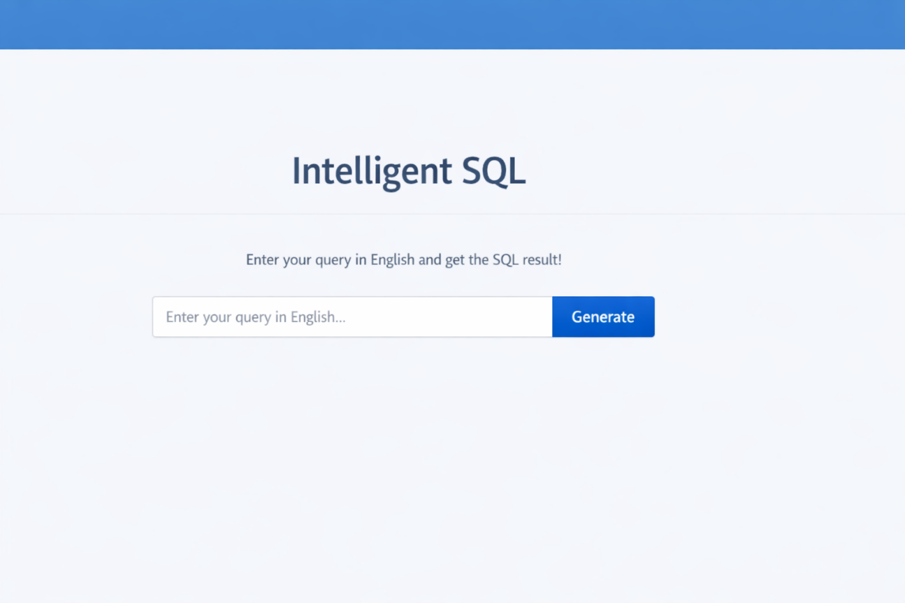
Home Page:

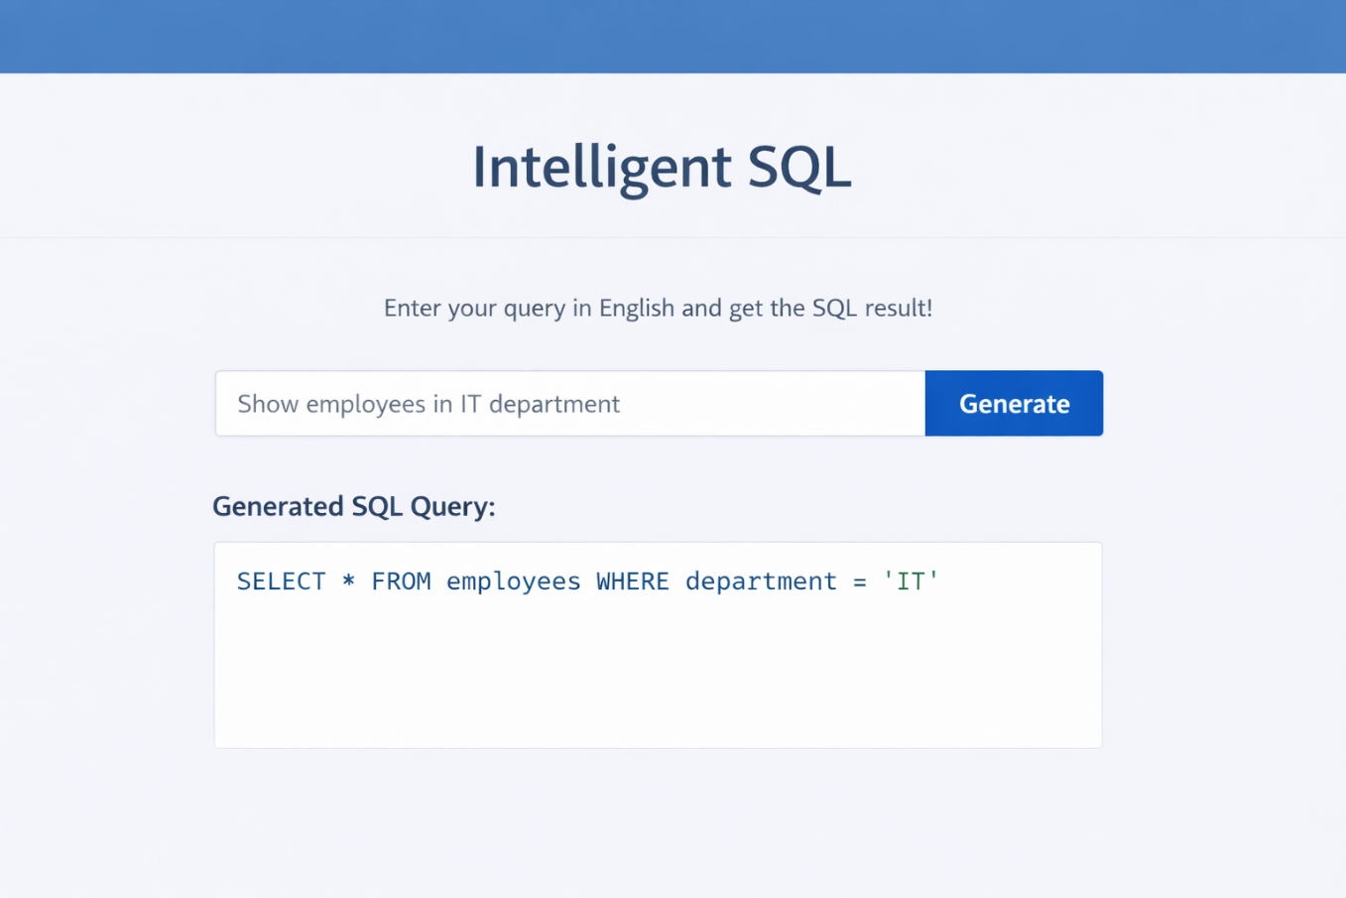
Query Input Page:

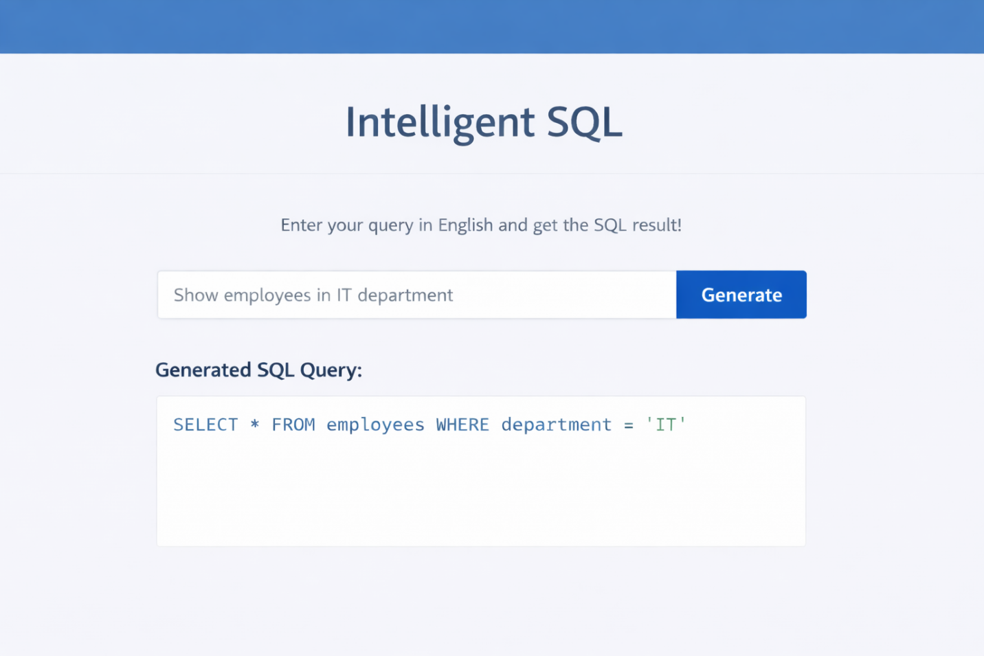
Generated SQL Query:

Result Table:
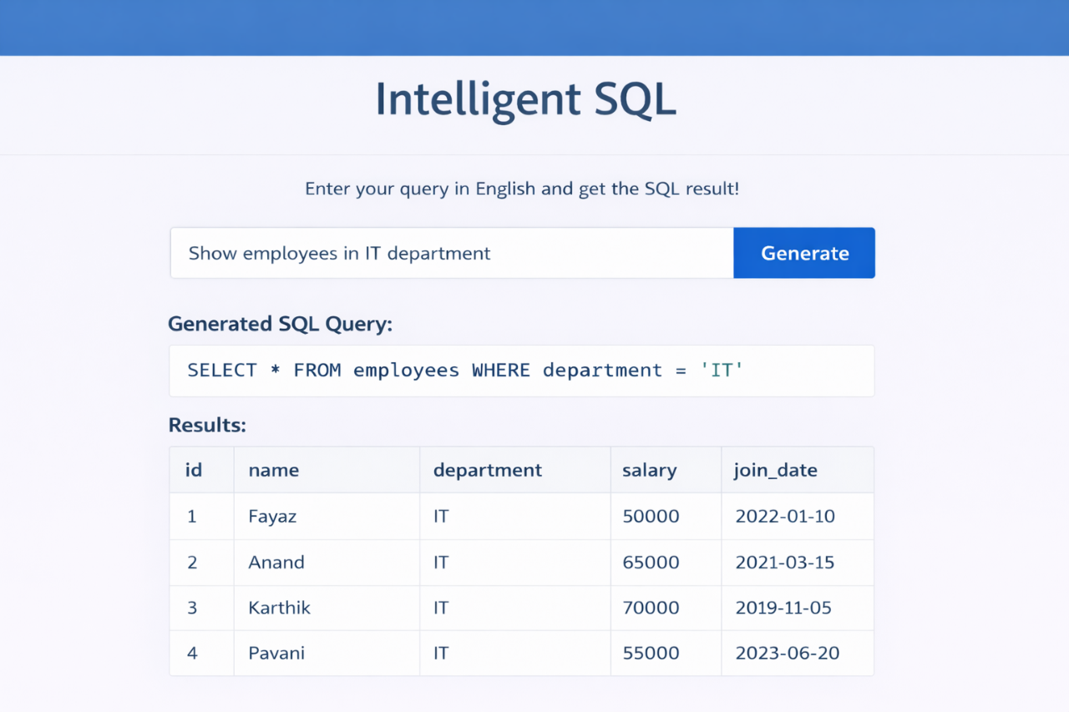

Error Handling Page:
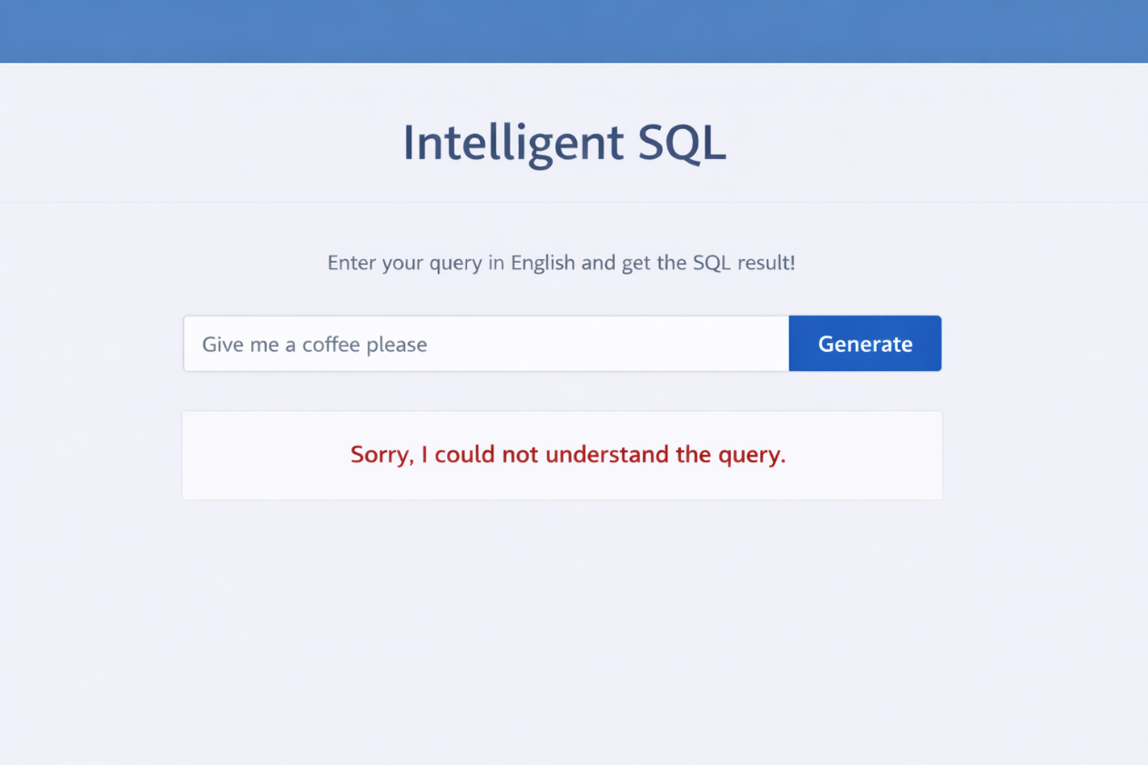

8.ADVANTAGES & DISADVANTAGES
Advantages
- Easy to use
- Saves time
- Reduces syntax errors
- Helps beginners
- Improves productivity
Disadvantages
- Complex queries may not convert perfectly
- Requires proper database schema understanding
- Accuracy depends on NLP model

9.CONCLUSION
The Intelligent SQL system successfully bridges the gap between natural language and database querying. It simplifies database interaction and enhances accessibility for users without SQL expertise.
The project demonstrates practical implementation of AI in database management systems.

10.FUTURE SCOPE
- Integration with voice assistant
- Multi-database support
- AI model improvement
- ChatGPT-like conversational interface
- Cloud deployment
- Query optimization suggestions

11.APPENDIX
Source Code
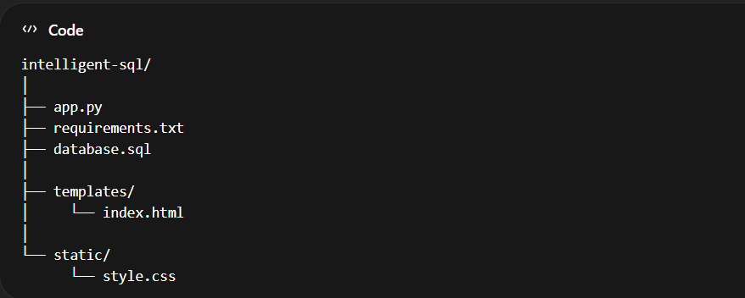

INSTALLATION
Step 1: Install Python Packages
pip install flask mysql-connector-python

or create requirements.txt:
flask
mysql-connector-python

Dataset Link:
Download the dataset from the below link

https://www.kaggle.com/datasets/rhuebner/human-resources-data-set

Below is the complete SQL code for your Intelligent SQL project using the given dataset structure and values.
This includes:
- Database Creation
- Table Creation
- Constraints
- Sample Inserts (based on your data)
- Useful Queries for Testing Intelligent SQL

1.Create Database:

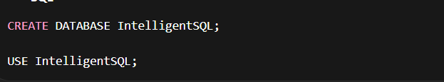

2. Create Table:
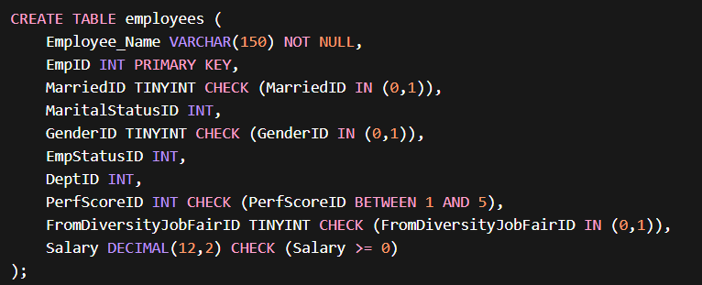

3.Inserting sample data (Based on data set):

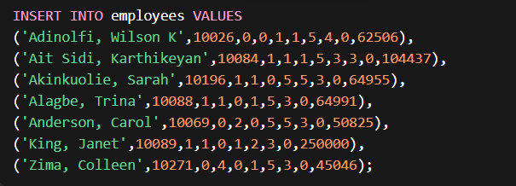

4.Useful Queries for Intelligent SQL Testing

These queries are helpful for your project demo.

Get All Employees:



Employees With Salary > 100000:

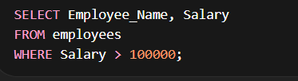

Count Employees By Gender:

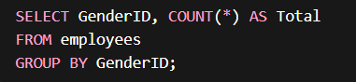

Married vs Unmarried Count:

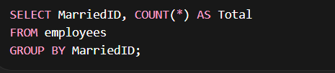

Highest Salary:

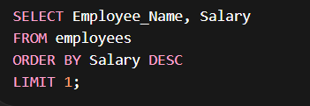

Employees From Diversity Job Fair:



Performance Score Distribution:

